2ND JUNE, 2026 CLASSWORK

CRUD OPERATIONS CODE
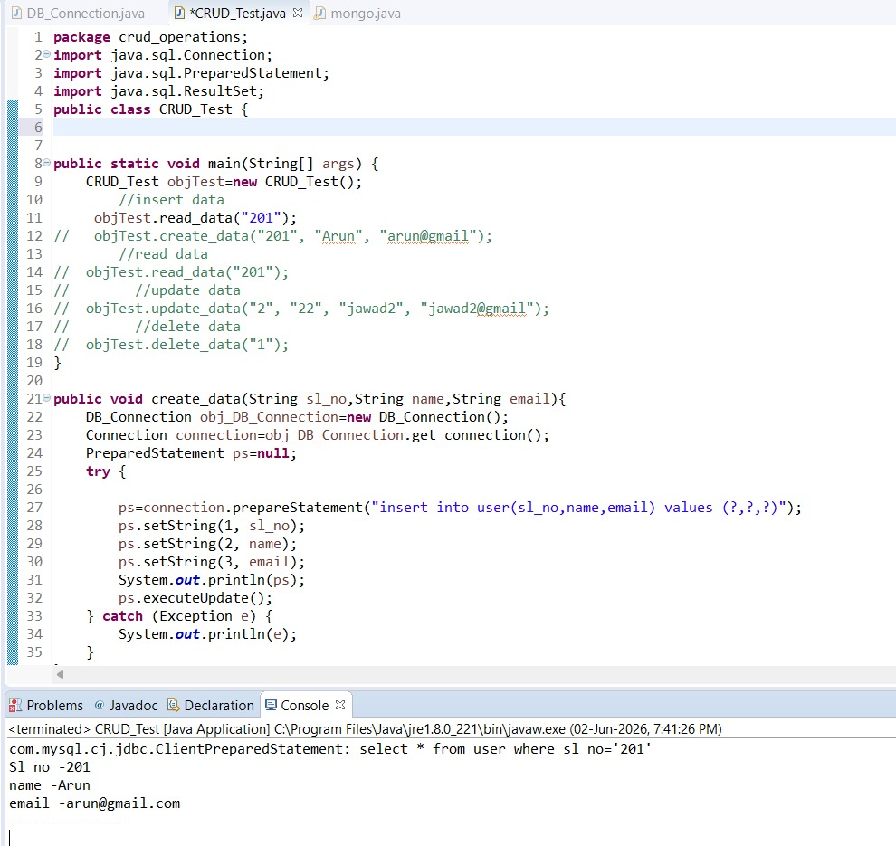

CRUD OPERATIONS - alter table
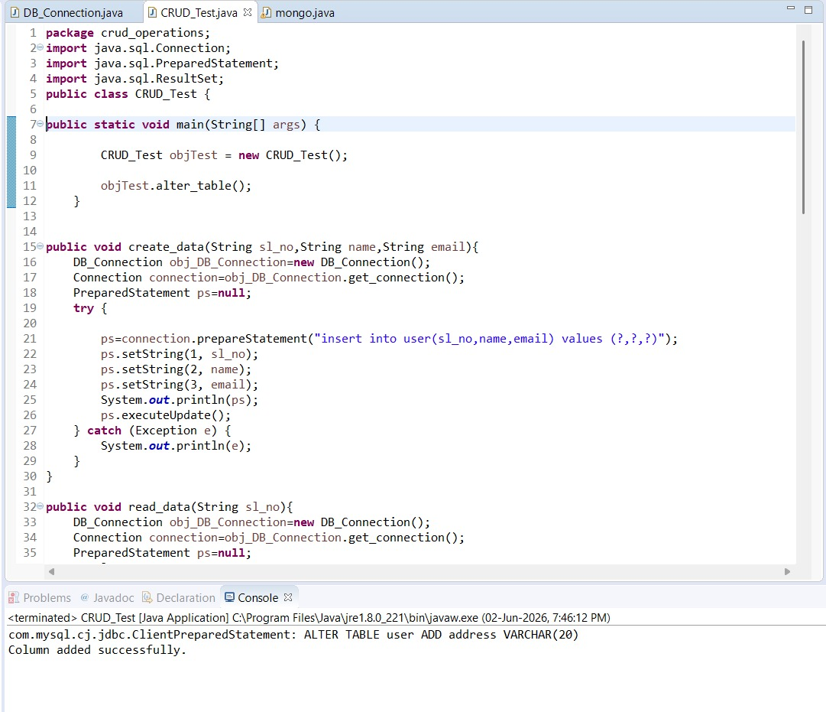

CRUD OPERATIONS - truncate table
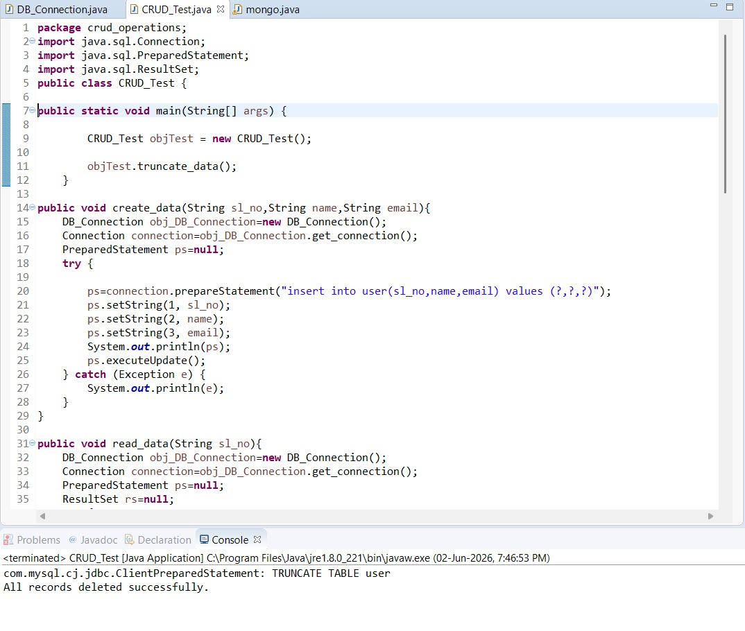

MONGODB CONNECTION
